**Artificial Intelligence in Enterprise Systems**

**Assignment #1– Flask**

**Value:** 5%

**Due:** End of Week 9

**Introduction:**

You have learned about Flask . In this assignment, you will develop RESTful API using Flask and perform CRUD operation. Database you will developed must have following fields in its table:

* student_id
* first_name
* last_name
* dob(date of birth)
* amount_due

You will be graded on following tasks:

|  |  |  |
| --- | --- | --- |
| item | Tasks | Marks |
| 1 | Creating Database | 15 |
| 2 | Creating Basic Flask App | 10 |
| 3 | For Create | 10 |
| 4 | For Read | 10 |
| 5 | For Update | 10 |
| 6 | For Delete | 10 |
| 7 | For Show all records | 10 |
| 8 | Presentation (Postman/Website) | 15 |
| 9 | Put your app in git repo | 10 |

**Submission:**

Submit a report using dropbox or DC connect and share your git repo

**This assignment relates to the following Course Learning Outcomes:**

CLO-2: Write industry standard code and use git to work in agile environment for developing enterprise AI products

CLO-5: Perform various DevOps operations (e.g., pytest) using various local and cloud technologies and Develops Flask API

CLO-6: Develop and deploy Enterprise AI solution pipeline using various technologies (i.e., Local, Dockers, Heroku or cloud)

1. Creating Database

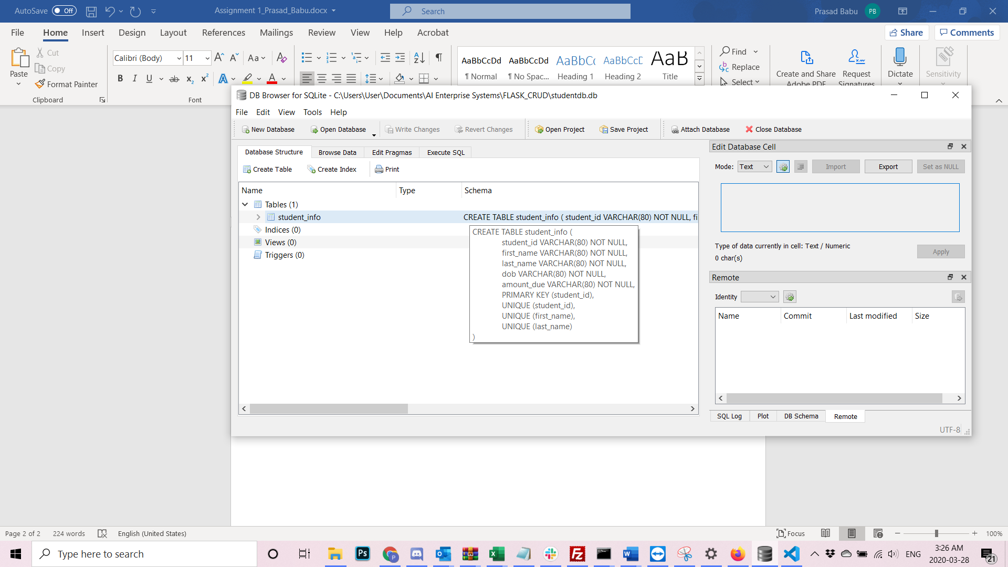

1. Creating Basic Flask App

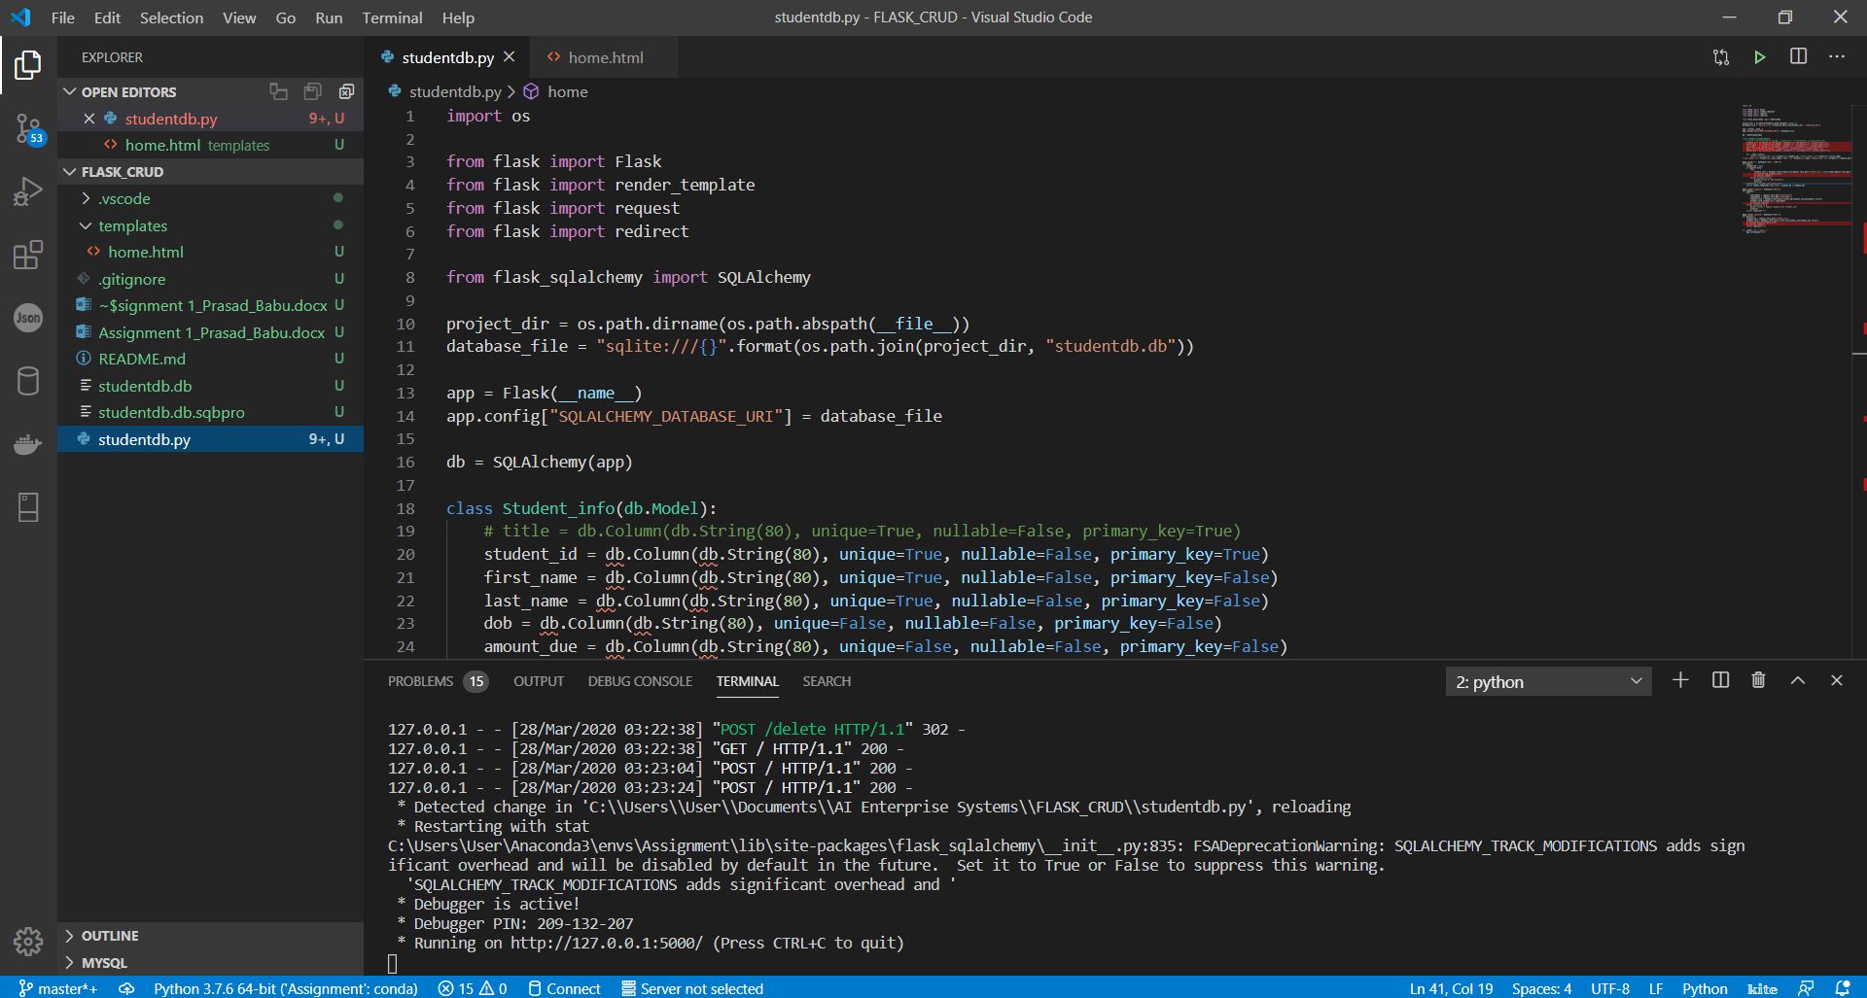

1. For Create 4. For Read 5. For Update 6. For Delete

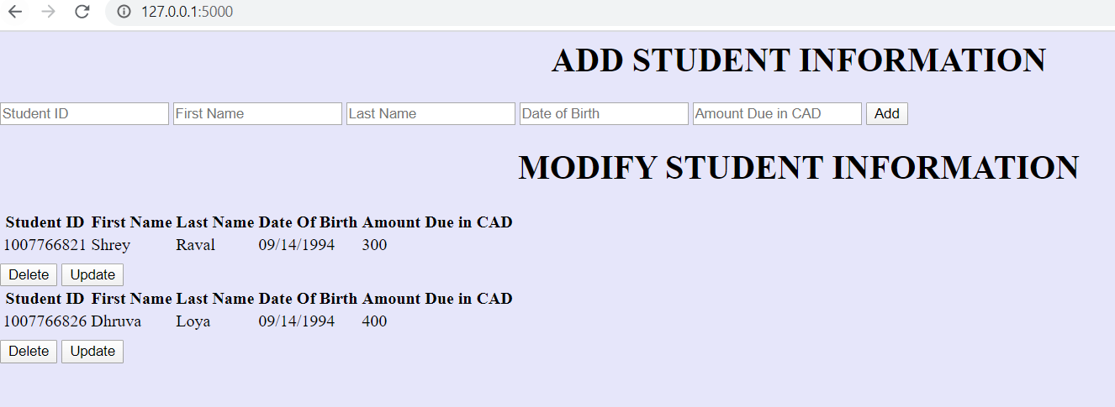

<<Read

<<Update

<<Delete

<<Create

1. For Show of all records

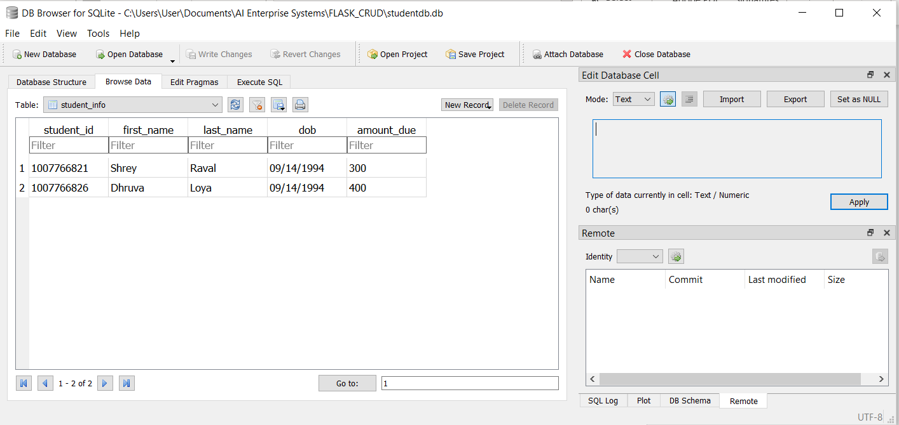

1. Presentation (Website/Postman)

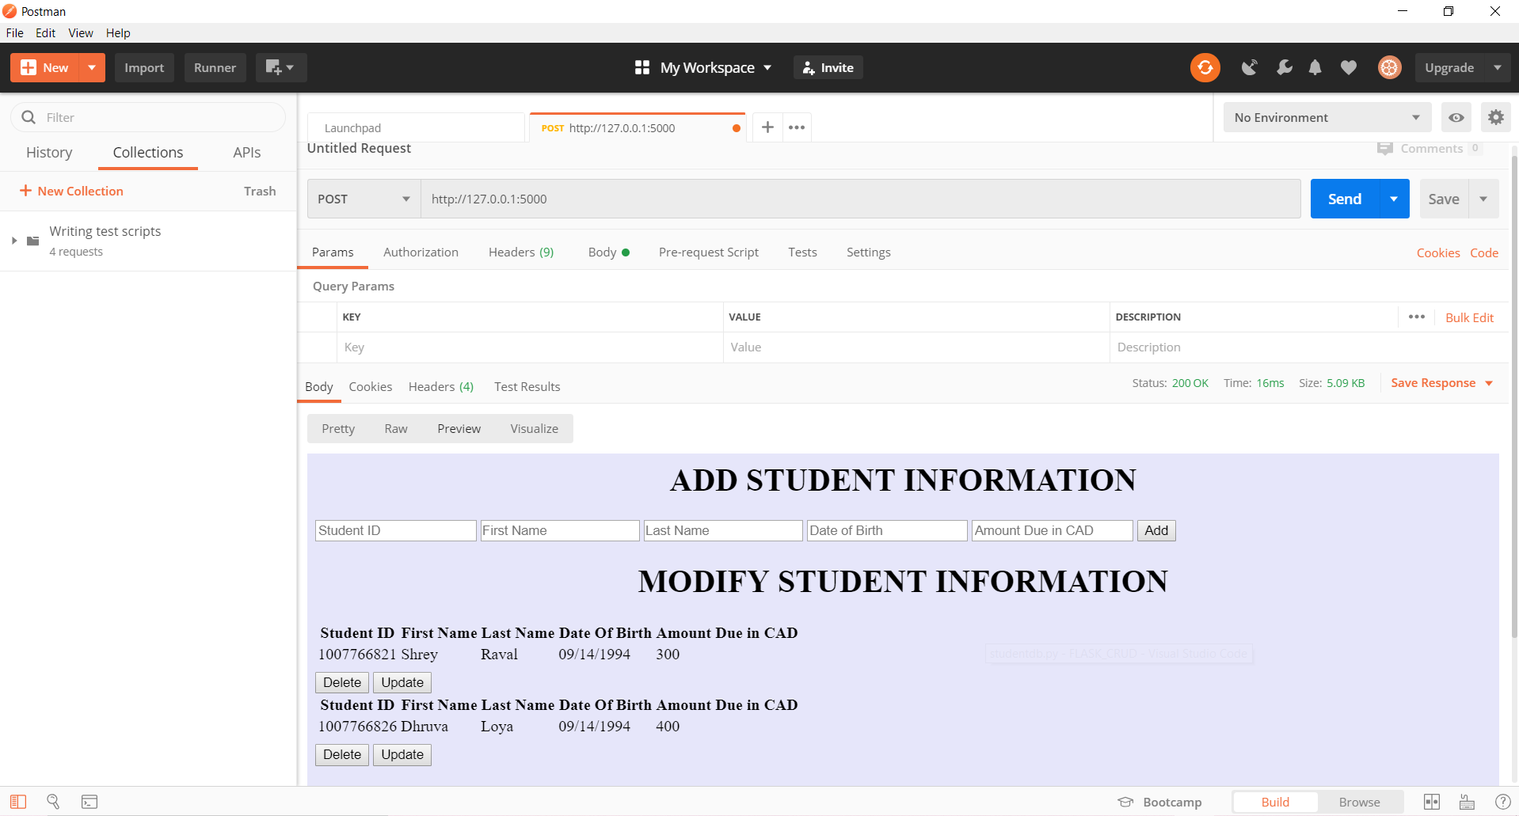

1. Put your app in Git Repo